|  |  |
| --- | --- |
| **D:\CE\WhatsApp Image 2021-05-08 at 4.35.03 PM.jpeg**    ***“CULTIVATING EXCELLENCE IN EVERY STUDENT”***  **‘**  **RAKESH KUMAR**  **M.Sc. (Chemistry) B.Ed.**  **CTET, PSTET, HPTET qualified**  **thakurkumar82@gmail.com** |  |
| **Class:-XII (Sci.) Name of Student……………………**  **Subject:- Chemistry**  **10 year QuStions**  **Chapter-10**  **Haloalkanes & Haloarenes** |  |

1. (a) Define the following terms : (i) Enantiomers (ii) Racemic mixture

(b) Why is chlorobenzene resistant to nucleophilic substitution reaction?

1. Write the reaction involved in the Hoffmann bromamide degradation reaction.
2. Give reasons for the following: (a) the presence of –NO2 group at ortho or para position increases the reactivity of haloarenes towards nucleophilic substitution reactions.

(b) p-dicholorobenzene has higher melting point than that of ortho or meta isomer. (c) Thionyl chloride method is preferred for preparing alkyl chloride from alcohols.

1. (a) Write equation for preparation of 1-iodobutane from 1-chlorobutane. (b) Out of 2-bromopentane, 2-bromo-2-methylbutane and 1-bromopentane, which compound is most reactive towards elimination reaction and why?
2. Why is chloroform kept in dark coloured bottles?
3. (a) Out of  , which one is more reactive towards SN2 reaction and why?

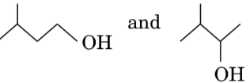(b) Out of which one is more reactive towards nucleophilic substitution reaction and why?

(c) Out of which one is optically active and why?

1. Out of Chlorobenzene and Cyclohexyl chloride, which one is more reactive towards nucleophilic substitution reaction and why?
2. Among all the isomers of molecular formula C4H9Br, identify (a) the one isomer which is optically active. (b) The one isomer which is highly reactive towards SN2. (c) The two isomers which give same product on dehydrohalogenation with alcoholic KOH.
3. (i) Out of (CH3)3C–Br and (CH3)3C–I, which one is more reactive towards SN1 and why? (ii) Write the product formed when p-nitrochlorobenzene is heated with aqueous NaOH at 443 K followed by acidification. (iii) Why dextro and laevo – rotatory isomers of Butan-2-ol are difficult to separate by fractional distillation?
4. An aromatic compound ‘A’ on heating with Br2 and KOH forms a compound ‘B’ of molecular formula C6H7N which on reacting with CHCl3 and alcoholic KOH produces a foul smelling compound ‘C’. Write the structures and IUPAC names of compounds A, B and C.
5. Predict the major product formed when sodium ethoxide reacts with tert.Butyl chloride.
6. Which one of the following compounds is more reactive towards SN2 reaction and why? CH3CH(C*l*)CH2CH3 or CH3CH2CH2C*l*
7. Write the product(s) formed when

(i) 2-Bromopropane undergoes dehydrohalogenation reaction.

(ii) Chlorobenzene undergoes nitration reaction. (iii) Methyl bromide is treated with KCN.

1. Draw the structures of the major monohalo product for each of the following reactions :

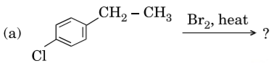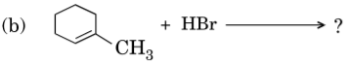

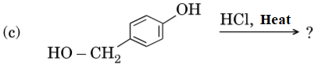

1. Following compounds are given to you: 2-Bromopentane, 2-Bromo-2-methylbutane, 1-Bromopentane (i) write the compound which is most reactive towards SN2 reaction. (ii) Write the compound which is optically active.

(iii) Write the compound which is most reactive towards β-elimination reaction.



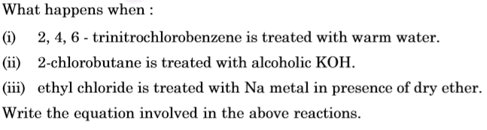

1. **…………………………………**
2. 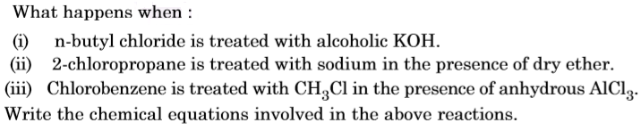
3. Give reasons: (i) C–C*l* bond length in chlorobenzene is shorter than C–C*l* bond length in CH3–Cl. (ii) The dipole moment of chlorobenzene is lower than that of cyclohexyl chloride. (iii) SN1 reactions are accompanied by racemization in optically active alkyl halides.
4. 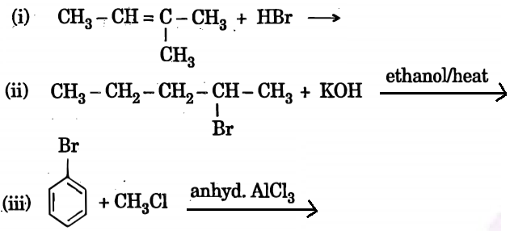Write the· structure of the major ·product in each of the · following reactions:
5. Give reasons: (a) n-Butyl bromide has higher boiling point than t-butyl bromide. (b) Racemic mixture is optically inactive. (c) The presence of nitro group (–NO2) at o/p positions increases the reactivity of haloarenes towards nucleophilic substitution reactions.

**……………………..**